­­­

CPNP Project

Curac Mihai-Ionuț

Pîșu Cristina

Radu Matei

Savu Cosmin-Claudiu

Group: 30443/2

Contents

1. Project Objectives
2. Architecture
3. Deployment

1. **Project Objectives**

The main objective of this project is to build an “energy management system”.

Regular users will be able to login into their accounts and see all of their assigned devices, while admin users will be able to perform CRUD on users and devices and also assign devices to users.

The system consists of a frontend and two microservices. All three components are deployed locally inside Docker containers, thus in the form of a microservice architecture, where each microservice is as decoupled as possible from the rest, while avoiding the emergence of a single point of failure.

1. **Architecture**

Below is a diagram describing the conceptual architecture of the system.

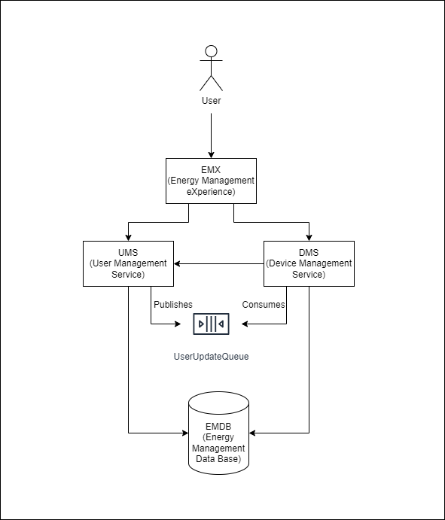

As it can be observed above, the EMX component (frontend) communicates directly with only the two microservices. The microservices both have a dependency on the database instance and, in addition, the DMS service also has an upstream dependency on the UMS service, both in synchronous (HTTP requests) and asynchronous form (consuming from the UserUpdateQueue, on which UMS publishes user deletion events). The role of the UserUpdateQueue is to ensure consistency between the tables of UMS and DMS, such that whenever a user is deleted by an admin, all existing relations between that given user and other table objects are as well deleted from the system (more specifically, in our case, all user-device mappings corresponding to the user in question).

1. **Deployment**

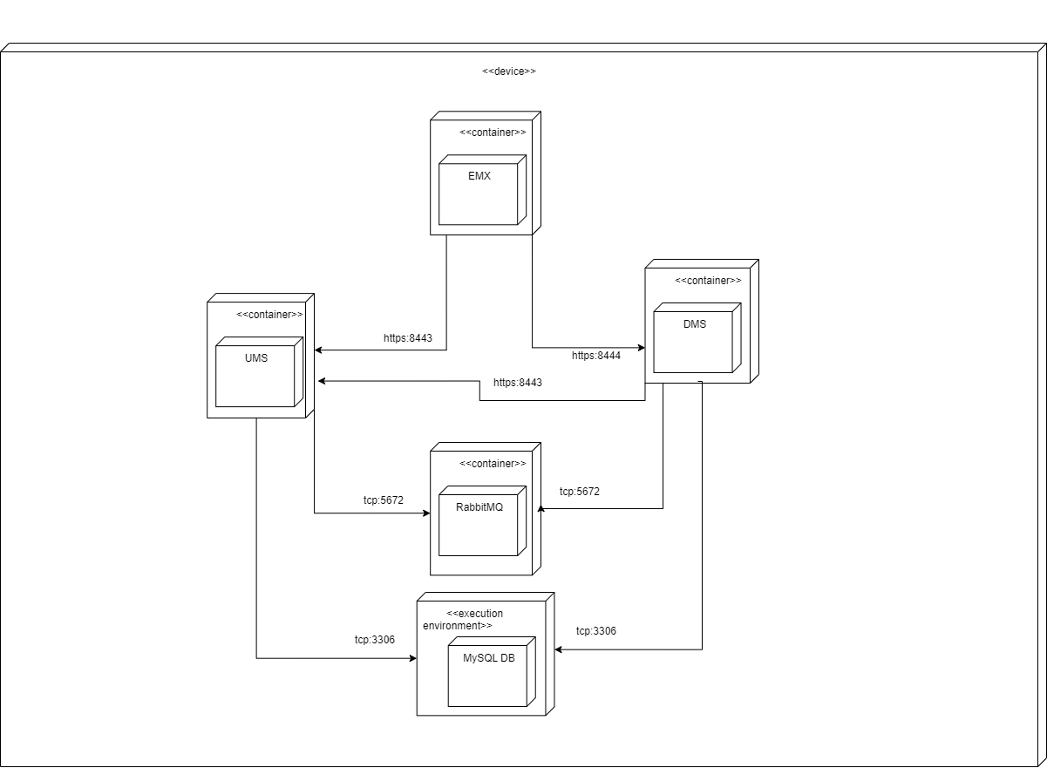As previously mentioned, the microservices are all deployed inside Docker containers on a local device, all communicating with each other. The RabbitMQ instance also runs inside a Docker container, the only exception being the MySQL DB instance, which runs directly on the host machine.